**Task 1: -**

**Make these buttons using HTML CSS**

Basic:-

Definition and Usage

The <button> tag defines a clickable button.

Inside a <button> element you can put text (and tags like <i>, <b>, <strong>, <br>, <img>, etc.). That is not possible with a button created with the [<input>](https://www.w3schools.com/tags/tag_input.asp) element!

**Tip:** Always specify the type attribute for a <button> element, to tell browsers what type of button it is.

**Tip:** You can easily style buttons with CSS! Look at the examples below or visit our [CSS Buttons](https://www.w3schools.com/css/css3_buttons.asp) tutorial.

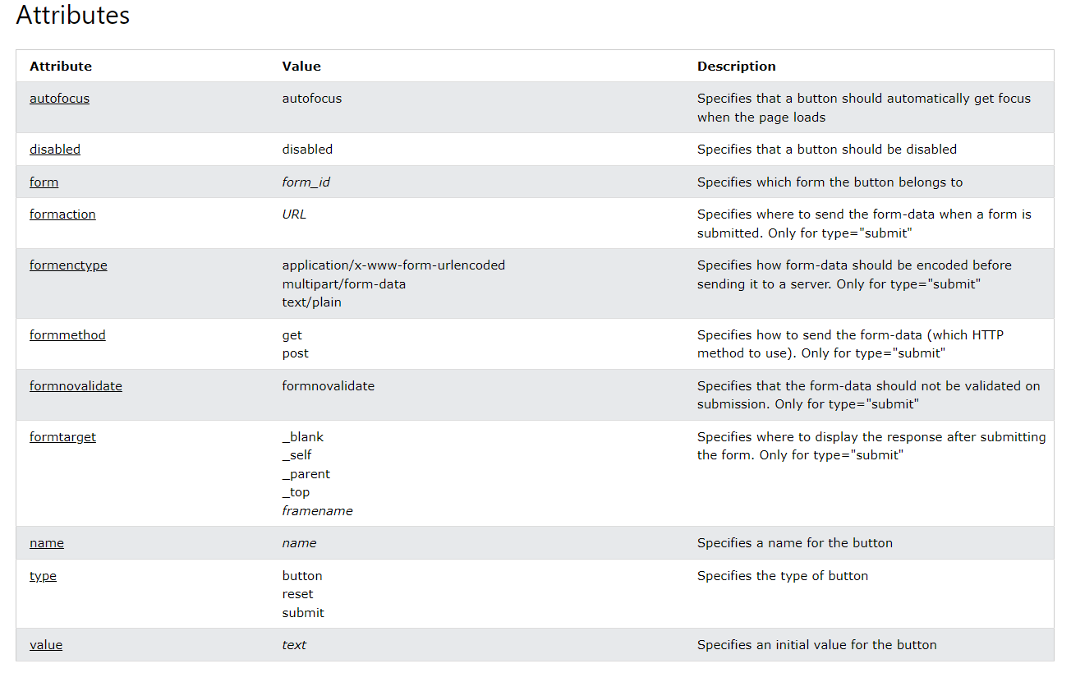

Result:

Task 2:

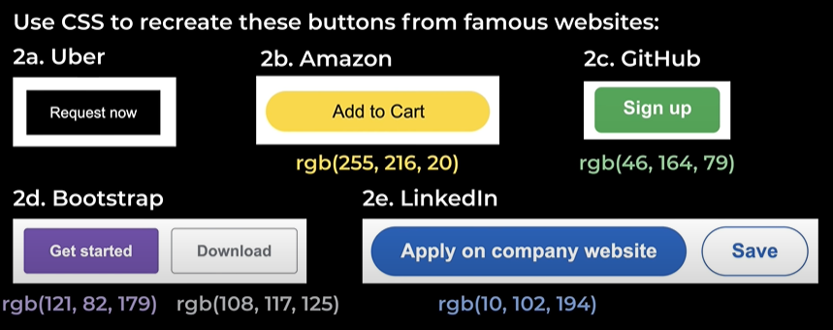

Result:-

**Hover – Transitions – Shadows**

.tweet{

    background-color: rgb(24, 157, 235) ;

    color: white;

    border: none;

    height: 35px;

    width: 65px;

    border-radius: 32px;

    margin: 5px;

Transition: property_name duration,

Another_property_name duration;

    font-weight: bold;

    cursor: pointer;

    transition: box-shadow 0.15s;

}

For adding shadow

.tweet:hover{

    box-shadow: 5px 5px 10px rgba(0,0,0, 0.15);

}

.tweet:active{

When Button is clicked!

    background-color: rgb(10, 115, 177) ;

}

**Void Element:-** A void element is an element whose content model never allows it to have contents under any circumstances. Void elements can have attributes.

Image, link, meta, doctype

Images:

.prac-img{

    width: 300px;

    height: 300px;

    border-width: 3px;

    border-color: red;

    border-style: solid;

    object-fit: contain;

    object-position: bottom;

}

Exercise 8:

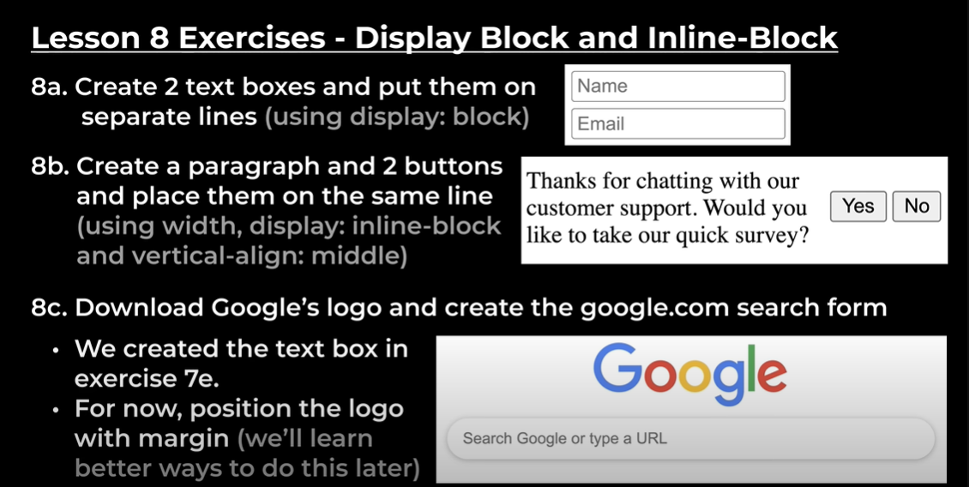

Solution:

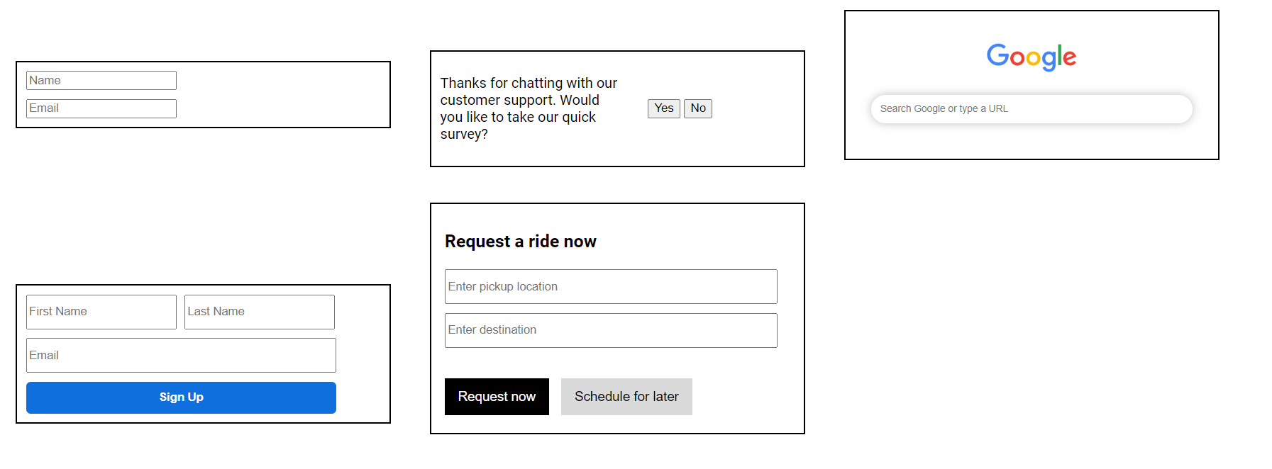

Exercise 9:-

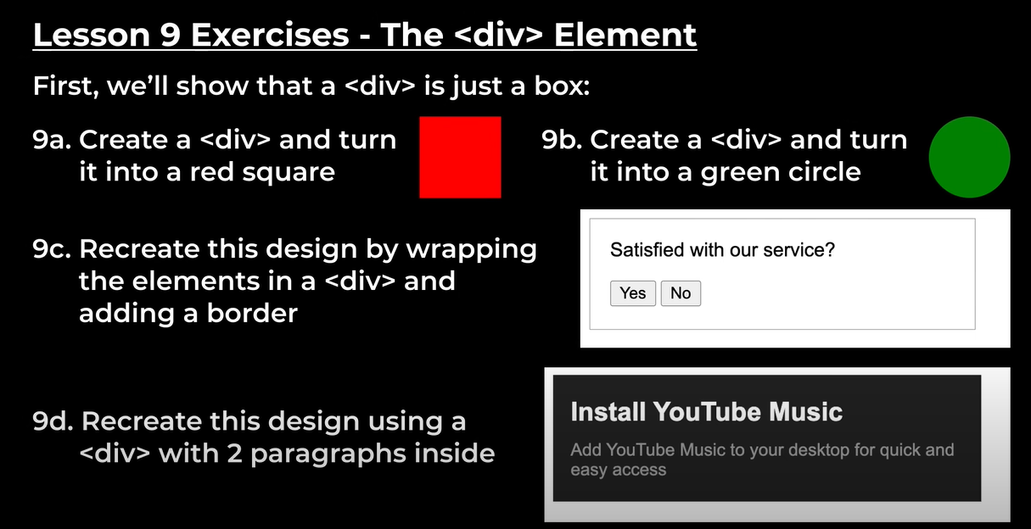

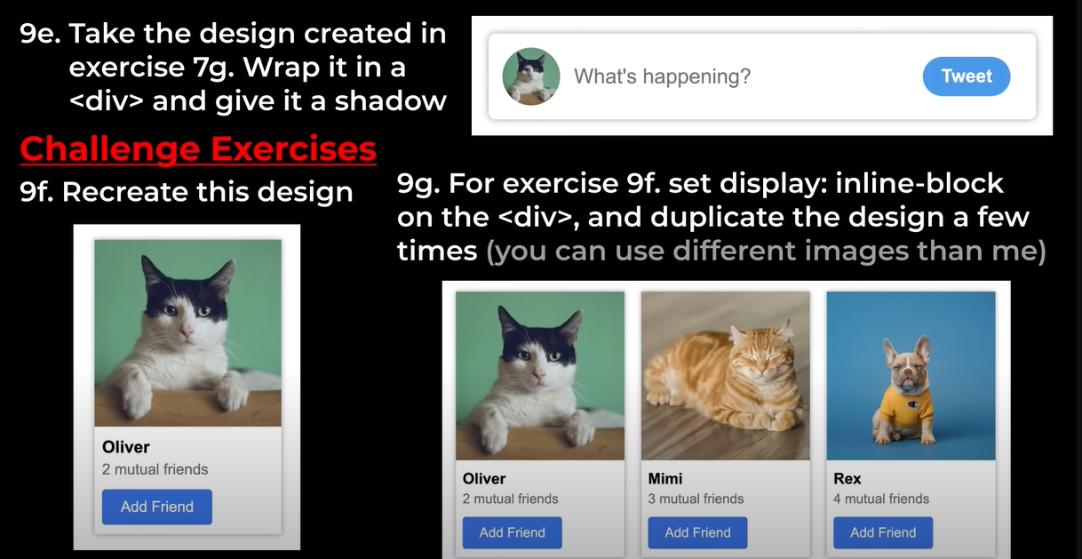

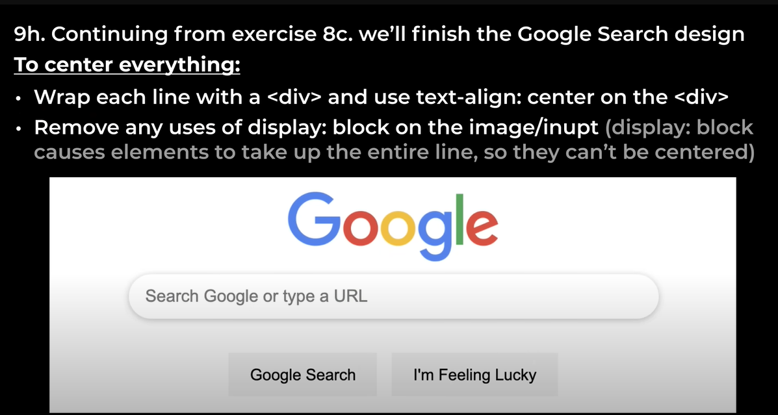

Answer:

Nested Layout Technique

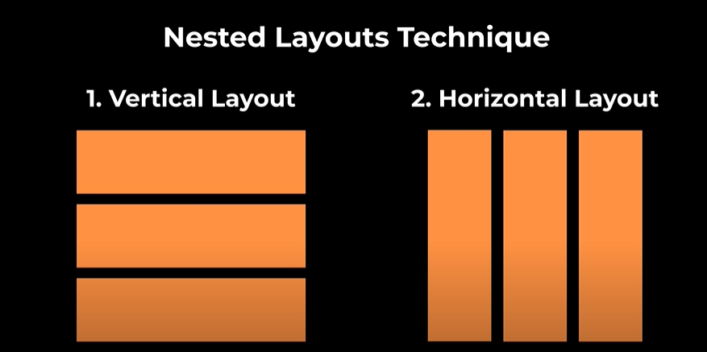



Exercise 10:

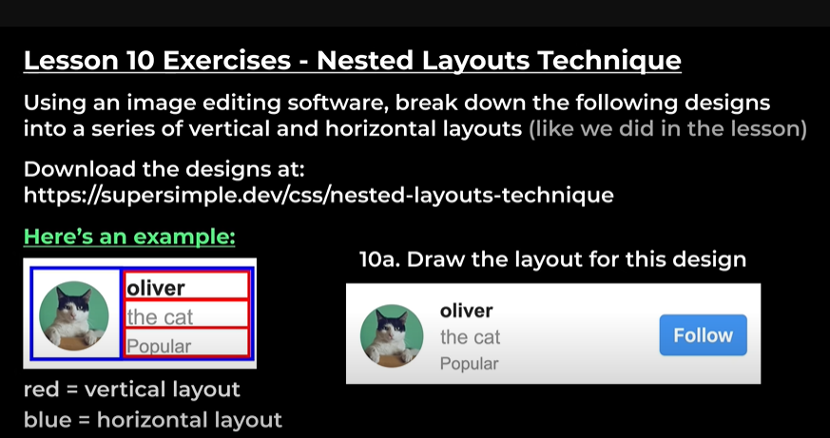

Answer:-



